Table of Contents

Graph-Based Screening for Potentially Cooperative Vessel Pairs
Subtitle: A temporal link prediction approach using AIS (2012–2019).

Abstract
Illegal, unreported, and unregulated (IUU) fishing motivates monitoring coordinated vessel behavior. This project builds an unsupervised pipeline: daily graphs from AIS (2012–2019), a Temporal Graph Convolutional Network (TGCN) for temporal link prediction, and independent geographic checks on raw tracks to prioritize high-scoring pairs. Training edges use a 10 km same-day proximity rule; stricter distance screens (e.g., 25 km) are validation-only. There are no labels for “cooperative” vessels—the model learns from graph structure and time, and outputs candidates for review, not ground truth.
Main quantitative result (Table 1): On the combined graph (proximity edges plus same–MMSI-prefix “social” edges, built with a corrected three-digit MID rule), a reproducible laptop run (1450 training time buckets, 3 epochs, seed 1) achieves ROC AUC = 0.72997 and AP = 0.71381 on 876 held-out daily buckets (artifacts/tgcn_social_maxb1450_ep3.json). A proximity-only full graph reaches higher scores (~0.78 AUC) under similar memory limits. A separate short August 2017 window is used only for an interpretability figure; its metrics are not comparable to the 2012–2019 benchmark. Eight candidate pairs pass a strict 25 km, ±1 day proximity filter. We do not claim legal findings or confirmed “dark fleet” membership.
Keywords: AIS, IUU fishing, temporal graph neural networks, link prediction, vessel co-movement

1. Introduction
Problem. Fisheries enforcement and research need ways to highlight vessels that may act together—transshipment, shared fishing grounds, or periods with missing AIS (“dark” behavior). Automatic vessel identification (AIS) provides large-scale movement data, but cooperation is rarely labeled in the data we use.
What this work does. We treat the problem as temporal link prediction on daily graphs: if the model assigns a high score to a vessel pair in a future time bucket, that pair is a candidate for analysts. We then validate candidates with simple proximity rules (distance between daily mean positions) and case studies (tracks, monthly overlap).
What this work does not do. We do not prove coordination or IUU activity; we provide a ranked list plus evidence that human review can interpret.
Contributions (short).
- Reproducible pipeline: AIS → daily graphs → TGCN with temporal node features → time-based train/test split.
- MID-correct combination of proximity and same-prefix social edges (scripts/mmsi_mid.py, scripts/add_social_edges.py).
- Reported full-coverage metrics under realistic laptop memory limits (train buckets capped where needed).
- Validation and interpretation: proximity filters, eight-pair overlap plots, and an August 2017 interpretability figure with country and gear on the vertical axis (from cell-level fleet joins where available).
Roadmap. §3 summarizes the link-prediction setup (full notation in Appendix C), then data, graph rules (10 km proximity + MID social edges), training objective, and post-hoc validation distances. §4 gives quantitative results (Table 1), geographic and interpretability figures (Tables 2–3, Figures 1–4), and Appendix A for gear definitions. §5–6 summarize limitations and conclusions; Appendix B lists reproducibility commands.
For readers and committees (three sentences). (1) Training graphs use 10 km same-day proximity edges (plus optional MID “social” edges); 25 km and wider checks are post-hoc validation, not class labels. (2) The headline 0.72997 / 0.71381 scores refer to the combined full-coverage graph in Table 1; proximity-only and capped rows are different experiments—see §3.6. (3) August 2017 figures illustrate behavior in a short window; do not mix their metrics with the 2012–2019 benchmark.

2. Background and related work
Fisheries monitoring and AIS. Illegal, unreported, and unregulated (IUU) fishing and at-sea coordination are active research areas. Large-scale studies use Automatic Identification System (AIS) broadcasts to map fishing effort and vessel encounters (e.g., global fisheries footprint and transshipment patterns—see References). AIS does not, by itself, label “cooperative” or illicit behavior; analysts typically combine movement data with proximity, registry, or enforcement context. That gap motivates unsupervised tools that rank pairs for review.
AIS-based fisheries and encounter analytics. Beyond footprint mapping, vessel-level AIS supports encounter and behavior analysis (e.g., transshipment and loitering—Miller et al., 2018; monitoring-system assessments—Park et al., 2020). That line of work motivates movement-based screening but often relies on rules or supervised targets when labels exist. Here we stay unsupervised at the learning stage and reserve geography for post-hoc validation.
Graph learning and link prediction. Co-presence is naturally a graph: vessels are nodes; edges encode same-day proximity (and optional same-registry structure). Graph convolutional encoders (Kipf & Welling, 2017) and inductive methods on large graphs (Hamilton et al., 2017) learn vector representations of nodes from topology and attributes. Link prediction scores missing or future links (Lü & Zhou, 2011); temporal graph models (e.g., spatio-temporal convolutions—Yu et al., 2018; recurrent or memory-based temporal graph networks—Rossi et al., 2020) apply when $G_{t}$ varies across $t$. Our implementation uses a TGCN-style recurrent update over daily snapshots with inner-product scores for pairs (see §3.4).
Evaluation philosophy. We use a chronological train/test split over daily buckets: train on earlier days, evaluate on later days. ROC AUC and AP therefore measure forecasting-style generalization to future co-occurrence, not i.i.d. mixing of time points (which can inflate scores when temporal drift is ignored).

3. Methods

3.1 Problem formulation
Each calendar day (bucket) $t$ defines a snapshot undirected graph $G_{t}=(V,E_{t})$: nodes $V$ are vessel MMSIs; edges $E_{t}$ follow the construction rules in §3.3—primarily same-day positions within 10 km (Haversine), plus optional same three-digit MID social edges. The learning task is temporal link prediction: a TGCN produces node embeddings so that inner-product scores between pairs rank observed edges above sampled non-edges under binary cross-entropy with logits, with no “cooperative” supervision—only structure and time (implementation: scripts/run_tgcn_time_multiseed.py and related; details §3.4). Train and test partition time buckets chronologically (~70% / ~30%); ROC AUC and AP measure ranking quality on held-out future buckets.
Appendix C lists symbols, restates the setup for readers who prefer a notation table, and separates training-edge distance (10 km) from validation-only distances.

3.2 Data and time buckets
We use AIS-derived records spanning 2012–2019, aggregated to daily resolution (~2.38B vessel-day records; sea-surface temperature merged where available). The timeline is divided into daily buckets; 876 buckets enter the main edge list used for evaluation.

3.3 Graph construction
- Nodes = MMSI identifiers (vessels).
- Proximity edges: same calendar day (daily time floor, typically 1D), pairwise great-circle (Haversine) distance at most 10 km between daily position summaries. The public full-coverage edge list edges_2012_2019_full.parquet is built with scripts/build_temporal_graph_baseline.py at this scale; builds may also apply a cap on edges per bucket to limit memory (see README.md for the exact command used per artifact).
- Social edges: undirected links between vessels sharing the same three-digit ITU MID (national/organizational MMSI prefix), derived with scripts/mmsi_mid.py so prefixes are not split on six digits. To keep graphs tractable, social edges are capped (e.g., up to 2000 per bucket in scripts/add_social_edges.py).
- Combined edge list for the primary social-augmented benchmark: artifacts/edges_full_with_social.parquet.
Validation distances (not training edges). Post-hoc proximity checks for candidates use 25 / 50 / 100 km (and optional ±1 day windows) on daily mean positions—different from the 10 km graph edge rule; §3.5.

3.4 Model and training objective
Architecture. Temporal Graph Convolutional Network (TGCN) with optional temporal node features (degree, interaction counts, partner diversity, recency, inter-event gaps—see scripts/build_temporal_node_features.py and README.md).
Training details (primary laptop benchmark). Unless noted otherwise: embedding dimension 32, Adam optimizer, learning rate 0.001, 3 training epochs over ordered training buckets, binary cross-entropy with logits comparing positive edges to randomly sampled negative pairs (same count as positives per snapshot). Chronological split ratio ~70/30 (--test-ratio 0.3 in training scripts). Train-bucket count was capped at 1450 for the headline combined-graph run due to laptop RAM (higher caps caused OOM).
Evaluation: ROC AUC and AP on test buckets; edge deduplication rules avoid trivial leakage of training links into the test objective (see code comments in the TGCN training scripts).
Computational cost. All experiments ran on a single laptop (Apple M-series, 16 GB unified RAM). The primary combined-graph run (1450 train buckets, 3 epochs) completed in roughly 20–40 minutes wall-clock depending on background load; peak resident memory sat near 12–14 GB, which is why bucket caps above ~1480 triggered the OS out-of-memory killer. The proximity-only full graph trained under similar constraints. Capped-graph runs and the short August 2017 window finished in under 5 minutes each. No GPU was used; all matrix operations ran on CPU via PyTorch. These numbers are approximate—the training scripts do not log wall-clock time or peak RSS automatically, so precise reproducibility of timing requires re-running under controlled conditions.

3.5 Heuristic validation (not supervised labels)
For candidate pairs we compute Haversine distance between daily mean positions and count days within 25 / 50 / 100 km (and ±1 day alignment where noted). This is post-hoc geography, not a training label.

3.6 Which numbers are “the same experiment”?
Readers should keep the following settings separate (do not mix metrics across rows):
Setting | Role
2012–2019 combined graph (proximity + social) | Primary benchmark—full timeline, social edges, reported AUC/AP on 876 test buckets.
Proximity-only graph | Ablation—no social edges; often higher AUC on this codebase; shows contribution of the social layer.
Capped / smaller graphs | Sanity checks and tuning—easier prediction; very high AUC; not the same difficulty as full global coverage.
August 2017 short window | Visualization only—few buckets; metrics are not comparable to the main table.

4. Results
§4 presents quantitative link-prediction metrics (Table 1), followed by geographic validation and interpretability figures. Recall from §3.6 that table rows represent different experimental settings—do not mix metrics across them.

4.1 Quantitative performance (TGCN)
Table 1 collects results across settings (see §3.6 for comparability notes).
Setting | Edge list | Train cap / notes | Test eval | ROC AUC | AP
Proximity-only, full | edges_2012_2019_full.parquet | ~1500 train buckets | time split | 0.77618 | 0.79549
Combined + social (primary laptop run) | edges_full_with_social.parquet | 1450 train buckets, 3 epochs, seed 1 | 876 test buckets | 0.72997 | 0.71381
Capped graph | capped parquet | tuning / easier task | — | ~0.95 | ~0.96
Capped (5-fold CV) | capped parquet | rolling CV | — | 0.927 ± 0.067 | 0.947 ± 0.048
August 2017 (case-study window) | short window | small | 5 test buckets | ~0.56 | ~0.67
Primary run details (combined row): embedding dimension 32, learning rate 0.001, temporal node features enabled. Artifacts: artifacts/tgcn_social_maxb1450_ep3.json and .csv. Increasing allowed training buckets (e.g., 400 → 1450) improved AUC/AP until memory limits on the laptop (~1480–1500 buckets caused OOM/killed). Further ablations: artifacts/tgcn_improvement_suite_summary.csv.
Proximity-only row source. The exact row values (0.77618 / 0.79549) come from artifacts/tgcn_time_temporal_nodes_fullcoverage.json.
Variability and uncertainty. The headline combined run is a single-seed report (seed = 1), so cross-seed confidence intervals are not available for the primary row. However, two other sources give a sense of variability:
- Per-bucket dispersion. Across the 876 test buckets the per-bucket standard deviation is ±0.103 for ROC AUC and ±0.106 for AP. Some days are easier (denser, more regular graphs) and others harder (sparser activity, regime shifts); the headline 0.72997 / 0.71381 is a macro-average over that distribution, not a claim that every day matches it. Per-bucket values: artifacts/tgcn_social_maxb1450_ep3.csv.
- Cross-seed reference (capped graph). On the easier capped graph, a 5-fold rolling-window CV with seeds 1–5 yields 0.927 ± 0.067 AUC and 0.947 ± 0.048 AP (Table 1). Cross-seed variance is modest there; extending multi-seed runs to the full-coverage graph is a priority for future work.
Why do social edges lower AUC? The proximity-only graph scores ~​0.78 AUC versus ~​0.73 for the combined graph. Three factors likely contribute:
- Noise from registry grouping. MID social edges link every pair of vessels sharing the same three-digit national prefix. In a predominantly Chinese-flagged dataset (MID 412), this connects thousands of vessels that never physically co-occur, injecting edges that the model must learn to discount.
- Over-smoothing. Adding dense social edges increases the effective neighborhood size for each GCN layer. When many neighbors are structurally similar but behaviorally unrelated, node embeddings blur toward a common mean, reducing the model’s ability to distinguish genuinely co-present pairs.
- Objective dilution. The training loss treats social edges and proximity edges identically (both are positive examples). The model therefore spends capacity fitting registry structure rather than geographic co-occurrence, which is the signal that carries over to unseen test days.
Disentangling these effects—e.g., by weighting social edges lower, using a heterogeneous-edge architecture, or tightening the MID cap—is listed under future work (§6).

4.2 Geographic validation and case studies
Among workflows that rank and check top candidates, eight pairs pass a 25 km, ±1 day rule. Examples: 412422375 ↔ 412428225 (about 2 days within 25 km); 412000690 ↔ 412325200 (102 days within 25 km). Detailed narratives and additional plots: docs/candidate_case_studies.md.
Figure 1 — why include a map? The model assigns abstract scores to vessel pairs. To verify that a high score corresponds to real-world co-movement, we plot raw AIS tracks on a map. Figure 1 shows our strongest candidate pair (412000690 ↔ 412325200, 102 days within 25 km) against the Chinese coastline in the Yellow Sea / East China Sea. If the model were surfacing random pairs, we would not expect their tracks to overlap geographically — but here they clearly do. This is visual validation, not proof of coordination. The eight-pair summaries in Table 2 and Figures 2–3 use a fixed full-coverage screen (slightly different pair list); Figure 1 is the flagship example.
How to read the figure:
- Blue lines trace every daily mean position for vessel 412000690; orange lines trace vessel 412325200, both spanning 2013 to 2018.
- The colored background is a combined daily presence density: for each vessel a smoothed density surface (2D kernel density estimation) is computed from all of its daily mean positions, then the two surfaces are summed and normalized to a 0–1 scale. The horizontal color bar at the bottom maps this scale:
  - Dark blue / purple (0.00–0.15) = low combined presence — neither vessel spent much time there.
  - Teal / green (0.15–0.45) = moderate combined presence — at least one vessel was present occasionally.
  - Yellow / orange / red (0.45–1.00) = high combined presence — one or both vessels were frequently located there; the warmest colors mark the densest overlap.
- Black contour lines with numeric labels (0.1, 0.3, etc.) outline specific density thresholds, making it easy to locate the core shared operating area.
- The warmest region (yellow-green, centered near ~121 E, 37–39 N off the Shandong Peninsula) is where daily positions from both vessels overlap most, consistent with a shared fishing ground in the Yellow Sea.
- Tan shading = land (10 m Natural Earth coastline); labeled cities (Shanghai, Qingdao, Jinan, Nanjing, Yancheng) provide geographic reference along the coast.
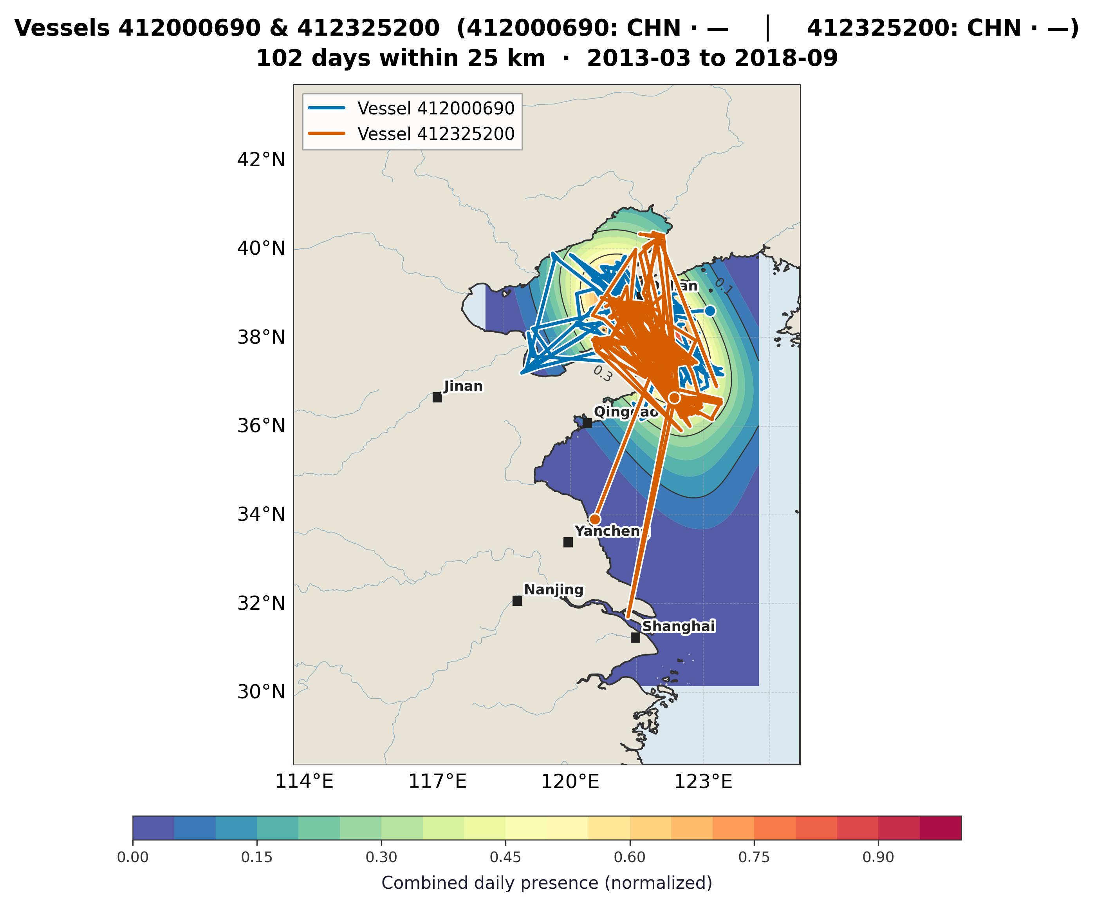
Figure 1. Vessel pair 412000690 (blue) and 412325200 (orange), Chinese coast, 2013–2018. Background = combined daily presence density (KDE, 0–1 scale; see color bar and “How to read” above). Takeaway: the model’s top-ranked pair shows sustained co-presence in the Yellow Sea (~121 E, 37–39 N), confirming the high link-prediction score corresponds to a real shared operating area. Tracks-only version: pair_412000690_412325200.png. Reproduce: Appendix B.

4.3 Monthly overlap and cluster context
Figure 2 charts the monthly count of days each validated pair’s vessels were within 25 km. Figure 3 maps those same rendezvous locations geographically and highlights a six-vessel subgroup near ~30 N, 122 E.
How to read Figure 2:
- Each row is one vessel pair, sorted from most overlap (top) to least (bottom). The y-axis label shows the pair number, the flag state(s) involved (e.g., CHN for China), and a summary line giving the total days and active months.
- Each bubble represents one calendar month. Bubble size is proportional to the number of days the two vessels were within 25 km that month (see the size legend in the upper right: 1, 5, 10, 20 days).
- Numbers inside larger bubbles give the exact day count for that month.
- Blank spaces mean zero close approaches that month — the pair was either not active or never came within 25 km.
- Alternating row shading (white / light gray) helps visually separate pairs.
- Color distinguishes pairs but carries no additional meaning beyond identification.
How to read Figure 3:
- Faint gray dots show all rendezvous points (monthly locations where any of the eight pairs were within 25 km).
- Colored markers (circles, squares, diamonds, triangles, crosses) each represent one of the six cluster vessels. The legend in the upper left identifies each vessel by abbreviated MMSI and flag state (all CHN).
- Thin gray lines connect cluster members that appear together as a pair, showing which vessels rendezvous with which.
- The red X marks the weighted hotspot centroid — the average location of all cluster rendezvous points (~29.7 N, 122.3 E).
- Tan land shading, coastlines, rivers, and labeled cities (Shanghai, Hangzhou, Ningbo, Wenzhou, Fuzhou) provide geographic reference.

4.3.1 Gear type codes (how to read “country · gear”)
Legend labels on Figures 2–4 and Tables 2–3 show country · gear per vessel. Country comes from the cell-fleet enrichment (artifacts/cooperative_pairs_with_flag_gear.csv) when the MMSI appears there, otherwise from the ITU MID prefix (e.g., MID111). Gear strings (e.g., trawlers, set_gillnets, fixed_gear, fishing) are geartype labels from cell-aggregated fleet files, assigned by hours-weighted overlap between MMSI daily cells and fleet rows (scripts/enrich_pairs_with_flag_gear.py). They indicate broad fisheries-activity categories, not a formal gear license per vessel. The em dash (—) means no gear could be attributed for that MMSI in the extract—common for the full-coverage pairs, which mostly fall outside the August 2017 enrichment window (see Table 2). Plain-language definitions of every code are in Appendix A.
Table 2 — Eight validated pairs (country · gear per vessel). Format: src MMSI, dst MMSI, then src country · gear | dst country · gear.
src | dst | Country · gear (src | dst)
412422375 | 412428225 | CHN · — | CHN · —
412437423 | 412435485 | CHN · — | CHN · —
412410128 | 412416248 | CHN · — | CHN · —
412461376 | 412415321 | CHN · — | CHN · —
412420679 | 412413383 | CHN · — | CHN · —
412985698 | 412443375 | CHN · — | CHN · —
412450427 | 111203412 | CHN · — | MID111 · —
412461376 | 412427825 | CHN · — | CHN · —
Table 3 — Six-vessel cluster (Figure 3). MMSIs selected by scripts/analyze_six_vessel_cluster.py; labels match plot legend.
MMSI | Country · gear
412413383 | CHN · —
412420679 | CHN · —
412427825 | CHN · —
412435485 | CHN · —
412437423 | CHN · —
412461376 | CHN · —
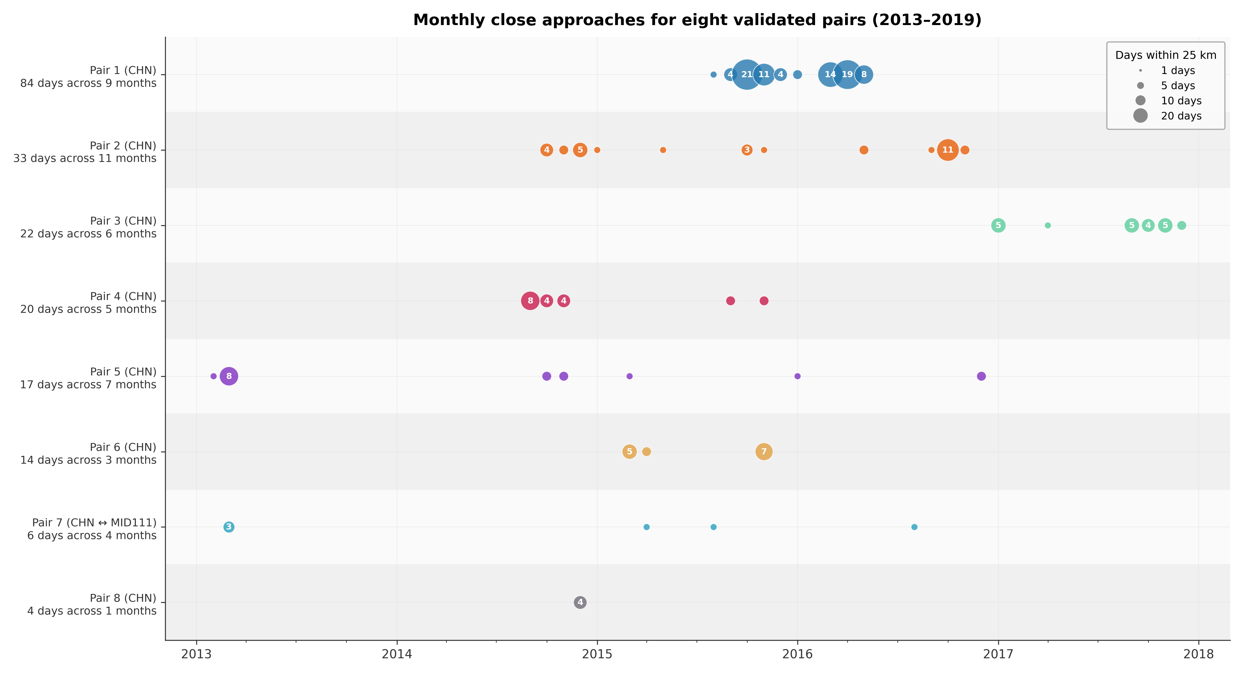
Figure 2. Bubble chart of monthly close approaches (days within 25 km) for all eight validated pairs, 2013–2019. Each row is one pair (sorted by total overlap, highest at top); bubble size is proportional to the number of days within 25 km that month; numbers inside larger bubbles show exact counts. Pair 1 (CHN, 84 days across 9 months) dominates with large, closely spaced bubbles in 2015–2016, indicating persistent co-presence over an extended period. Most other pairs are sporadic — a handful of small bubbles scattered across different years — suggesting occasional rather than sustained proximity. Pair 7 (CHN and MID111) is the only cross-flag pair. Y-axis labels show total days and active months per pair.
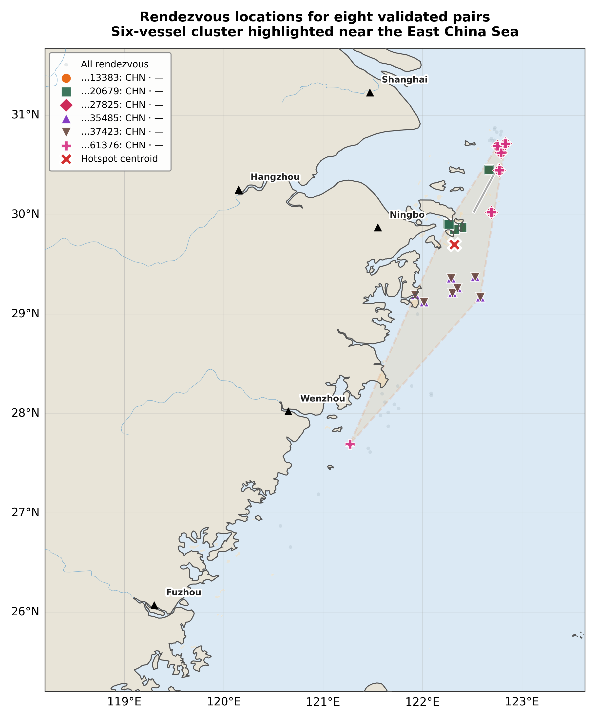
Figure 3. Geographic scatter of rendezvous locations for all eight validated pairs, plotted against the Chinese coast from Fuzhou to Shanghai. Faint gray dots show every recorded rendezvous point; colored markers (see legend) highlight the six cluster vessels (all CHN-flagged, abbreviated MMSIs in legend). Gray lines connect cluster members that co-occur as a pair. The red X marks the weighted hotspot centroid (~29.7 N, 122.3 E), sitting in the East China Sea roughly 50–80 km offshore from Ningbo. Most cluster activity is concentrated in a narrow band between 29 N and 30.5 N, while a few outlier points appear further south near Wenzhou. Takeaway: six vessels from multiple distinct pairs converge repeatedly on the same offshore area east of Ningbo, suggesting a shared operating region rather than coincidence — consistent with the co-presence patterns in Figure 2.

4.4 Exploratory short-window analysis (August 2017; not the main benchmark)
Why August 2017? The main TGCN benchmark (Table 1) spans 2012–2019 but produces abstract link-prediction scores with no fleet metadata attached. The cell-level fleet enrichment files that supply country and gear labels are only available for August 2017—that is the one window where model outputs can be joined to fleet context and interpreted in terms of what kinds of vessels were flagged. A separate, smaller TGCN run was therefore trained on this narrow slice (five daily buckets, Aug 7–11) so that cooperation predictions could be cross-referenced with gear type and flag state. The resulting metrics (~0.56 AUC, ~0.67 AP) are not comparable to the headline 2012–2019 scores; this window exists purely for interpretability.
Figure 4 summarizes those predictions across all 61 pairs observed during the five-day window. The left panel breaks down cooperative pairs per day by gear-type group; the right panel shows the flag-state composition of cooperative pair-days. The four gear groups in the chart are:
- Trawlers (blue) — both vessels in the pair are classified as trawlers (vessels that tow nets through the water or along the seabed). This is the single largest category.
- Line fishing (orange) — at least one vessel uses hook-and-line or generic fishing methods (includes pairs labeled fishing, fishing | trawlers, fishing | set gillnets, etc.).
- Set gear (green) — pairs involving stationary or deployed gear: set gillnets (nets left in place for fish to gill in the mesh), set longlines (long lines with baited hooks left to soak), or pole-and-line methods.
- Other / mixed (gray) — pairs where gear is unknown (em dash) for one or both vessels, or combinations that do not fit the above groups (e.g., purse seines).
Full definitions of every individual gear code are in Appendix A.
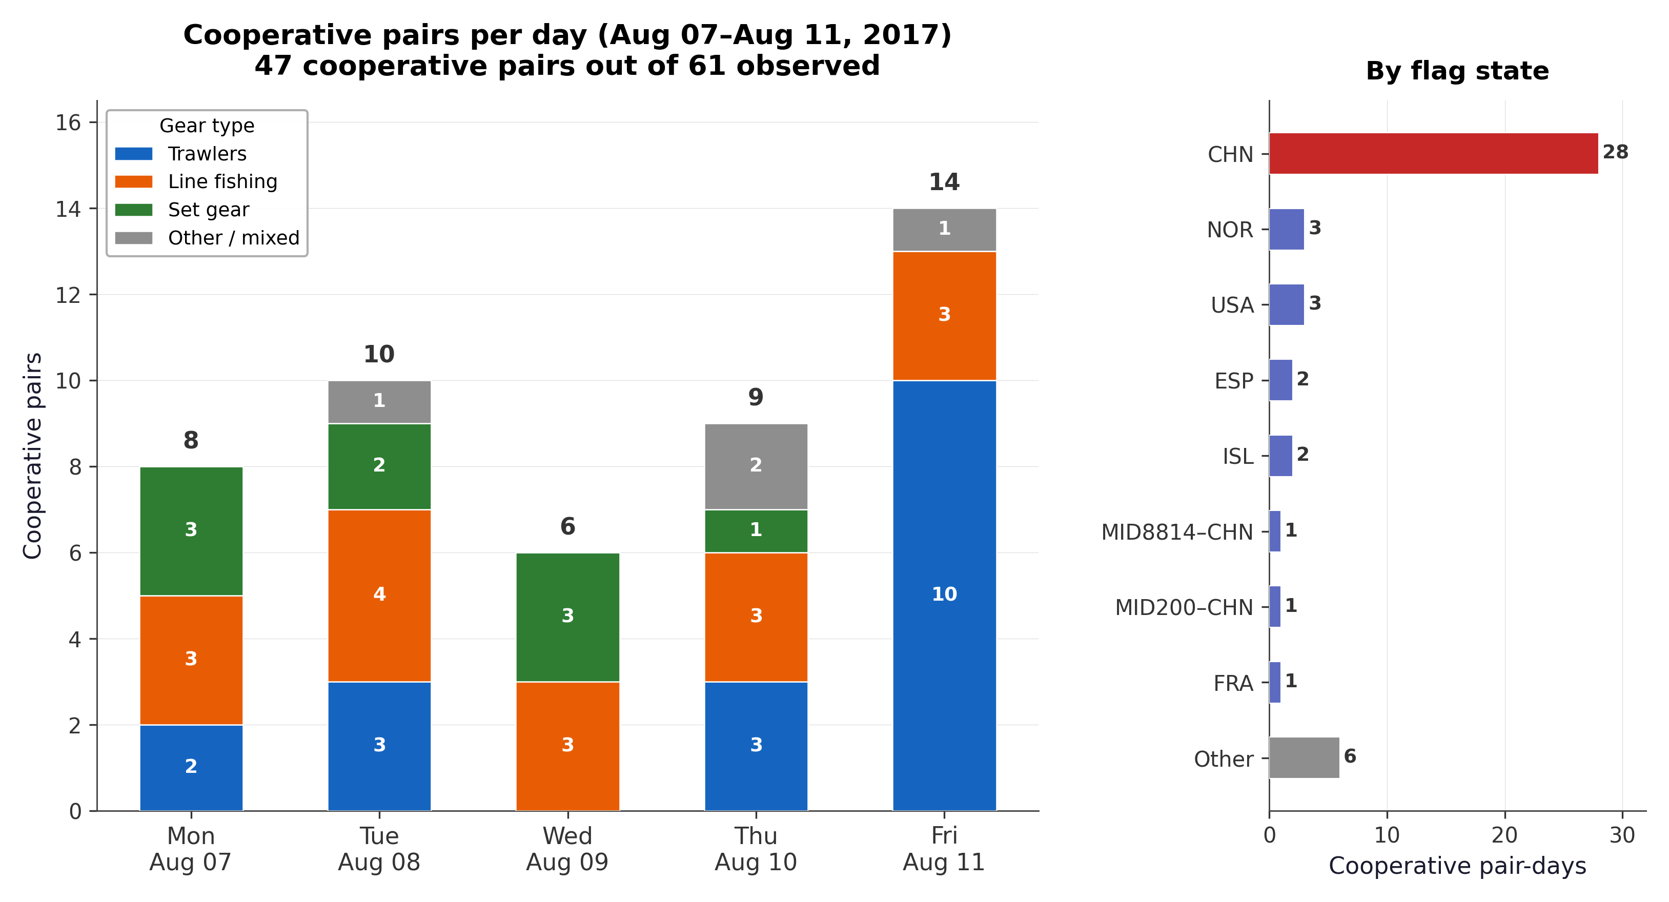
Figure 4. Aggregate cooperation summary (Aug 7–11, 2017). Left: stacked bar chart of cooperative pairs per day, colored by gear-type group. Numbers inside each segment show the count; daily totals are labeled above. Right: flag-state breakdown of all cooperative pair-days. Takeaway: cooperation predictions are spread across the full five-day window, with trawler–trawler pairs (blue) accounting for the largest share on most days and Chinese-flagged vessels (CHN, red bar) dominating the country breakdown. Friday (Aug 11) had the most cooperative pairs (14), driven almost entirely by trawlers.

5. Limitations

5.1 Threats to validity (why high scores ≠ “guilt”)
- Link prediction is not a verdict. ROC AUC / AP measure ranking of observed vs sampled non-edges under the graph definition. A model can score well when vessels share fishing grounds, ports, or traffic lanes—behavior that is legal and common.
- AIS selection and compliance. Vessels may disable AIS, use identity changes, or have sparse coverage; the graph only sees reported positions.
- Confounding by density. Crowded regions produce many possible edges; degree and popularity effects can inflate link-prediction metrics relative to “rare coordination.”
- Metric–semantics gap. Good calibration of the learning objective does not imply validated enforcement outcomes; external ground truth would be needed for that (we have none for cooperation).

5.2 Design and data constraints
- No behavioral ground truth for “cooperation” or IUU.
- Grid and sampling choices affect positions and edges.
- Laptop memory caps training buckets (1450 stable here; higher values failed).
- August 2017 is a narrow window—patterns there may not generalize.
- Shared geography vs coordination: overlap in dense regions is ambiguous (see §5.1).
- Country and gear on plots come from cell-aggregated fleet tables (§4.3.1, Appendix A)—descriptive context, not a formal registry. Gear labels should support interpretation only, not enforcement decisions.
- Single-seed headline numbers. The primary combined-graph AUC/AP is from one seed; per-bucket dispersion and cross-seed references are discussed in §4.1, but full multi-seed CIs on the headline row remain future work.

6. Conclusion and future work
We presented an unsupervised AIS→graph→TGCN pipeline with a time-split evaluation and an explicit link-prediction formulation (§3.1; Appendix C). The combined proximity + MID-correct social graph yields 0.72997 ROC AUC and 0.71381 AP on 876 test buckets under the documented laptop protocol (Table 1), alongside proximity-only and capped-graph comparisons. Eight pairs pass strict post-hoc proximity screening (Table 2); interpretability figures add country and gear context where data allow (Appendix A). For practice, the output is a ranked candidate list plus reproducible geographic and fleet-context checks—not a determination of wrongdoing. We do not claim confirmed coordination or IUU.
Future work includes finer spatial/temporal resolution; owner or fleet metadata from registries; supervised or semi-supervised learning when reliable labels exist; tighter integration of movement-based gear or behavior classifiers; full-coverage multi-seed runs and larger training-bucket budgets on high-memory hardware; heterogeneous-edge or edge-weighted architectures to better exploit social edges without the over-smoothing and noise effects described in §4.1; and continued care in separating benchmark metrics (2012–2019) from illustrative short windows (e.g., August 2017).

References
- Kroodsma, D. A., et al. (2018). Tracking the global footprint of fisheries. Science, 359(6378), 904–908.
- Miller, N. A., et al. (2018). Identifying global patterns of transshipment behavior. Frontiers in Marine Science, 5, 240.
- Park, J., et al. (2020). A systematic assessment of vessel monitoring data for identifying suspicious transshipment events. ICES Journal of Marine Science.
- Kipf, T. N., & Welling, M. (2017). Semi-Supervised Classification with Graph Convolutional Networks. ICLR.
- Hamilton, W. L., Ying, R., & Leskovec, J. (2017). Inductive Representation Learning on Large Graphs. NeurIPS.
- Yu, B., Yin, H., & Zhu, Z. (2018). Spatio-Temporal Graph Convolutional Networks: A Deep Learning Framework for Traffic Forecasting. IJCAI.
- Seo, Y., et al. (2018). Structured Sequence Modeling with Graph Convolutional Recurrent Networks. ICONIP.
- Rossi, E., et al. (2020). Temporal Graph Networks for Deep Learning on Dynamic Graphs. ICML Workshop on Graph Representation Learning.
- Lü, L., & Zhou, T. (2011). Link prediction in complex networks: A survey. Physica A, 390(6), 1150–1170.

Appendix A — Gear type codes
Plain-language definitions for gear strings in Tables 2–3 and Figures 2–4. The same content is kept in the repository as docs/gear_types.md for version control and easy editing.

A.1 Source of labels
In this project, gear on figures and tables comes from cell-level fleet aggregates, not from a per-vessel registry. For each MMSI–day, we join AIS daily cells to fleet files where each row is hours by flag × geartype in that cell; the vessel is labeled with the geartype that receives the most weighted hours that day (scripts/enrich_pairs_with_flag_gear.py). The label is a coarse, behavioral proxy for “what kind of fishing that cell’s traffic was attributed to,” not a formal gear certificate for the MMSI.
Plots use — when no gear could be attributed (vessel missing from the join, or no overlapping fleet rows).

A.2 Codes in artifacts/cooperative_pairs_with_flag_gear.csv
These strings are taken as-is from the fleet geartype column (snake_case).
Code (CSV) | Short gloss
fishing | Generic / unspecified fishing. Catch-all category in the source data when activity is attributed to “fishing” without a more specific gear class. Treat as low specificity compared to trawlers, nets, etc.
trawlers | Trawling. Vessels tow nets through the water column or along the bottom (e.g. otter trawl, beam trawl). High mobility; distinct from fixed or set gear.
fixed_gear | Stationary gear fixed to the seabed or structure: pots, traps, stakes, weirs, and similar non-towed gear that stays in place. (Name reflects “fixed” position, not “repaired.”)
set_gillnets | Set gillnets. Nets set and left (anchored, on bottom, or sometimes drifting) so fish gill in the mesh. Not actively towed like a trawl.
set_longlines | Set longlines. A long line with many baited hooks, deployed and left to soak (demersal or pelagic longline, depending on fishery).
other_purse_seines | Purse seining (other). A surrounding net used on schooling fish; the bottom is pulled closed (“pursed”) like a drawstring. “Other” indicates a sub-type bucket in the source taxonomy (not necessarily “miscellaneous quality”).
pole_and_line | Pole-and-line / baitboat. Fish caught with hand-held poles and hooks, often with live bait; common in some tuna fisheries.

A.3 How to interpret labels
- Same MMSI, different days can get different geartypes if the vessel moves between cells dominated by different fleet attributions.
- Same geartype on two MMSIs does not prove they use identical gear—only that both were attributed the same coarse class in that August 2017 window (where enrichment applies).
- AIS “ship type” codes differ from fleet geartype here: the latter is fisheries-activity oriented, not the full IMO/AIS ship-type list.
Methodology of the join and weighting: scripts/enrich_pairs_with_flag_gear.py and §4.3–4.4 of this report.

A.4 Related work (not from the same CSV)
The repository also includes a movement-based gear classifier trained on anonymized labeled tracks (see project README.md, “Gear classification”). Those class labels (e.g. purse_seines, trollers) are not automatically the same strings as the fleet geartype column above; do not merge them without an explicit mapping.

Appendix B — Reproducibility
Item | Command / path
Combined edges | python3 scripts/add_social_edges.py --edges artifacts/edges_2012_2019_full.parquet --out artifacts/edges_full_with_social.parquet --max-social-per-bucket 2000
Primary TGCN JSON/CSV | artifacts/tgcn_social_maxb1450_ep3.json, .csv — PyG env, PYTHONPATH=scripts
Optional per-bucket metric plots (not in main report) | python3 scripts/plot_tgcn_bucket_metrics.py --report artifacts/tgcn_social_maxb1450_ep3.json --out-dir artifacts/plots
Case study track plots (Figure 1) | python3 scripts/compute_pair_overlap_from_daily.py --pairs artifacts/case_study_pairs.csv --daily-root "data/MMSI daily vessels " --top-k 4 --distance-km 25 --day-window 1 --max-files-per-year 0 --out-dir artifacts/plots/case_study_pairs --contour — --max-files-per-year 0 uses all daily CSVs (default); a small number undercounts overlap days vs docs/candidate_case_studies.md. --contour: combined daily presence density (sum of two 2D KDE surfaces, Spectral_r colormap, labeled iso-lines, colorbar). With cartopy installed, the plot includes coastlines, land fill, rivers, and city labels for geographic context. First pair → pair_<src>_<dst>_contour.png + tracks-only pair_<src>_<dst>.png. Optional --out-summary. --contour-all-pairs for contour files on every pair.
Ablations | scripts/run_tgcn_improvement_suite.py → artifacts/tgcn_improvement_suite_summary.csv
August cooperation summary (Figure 4) | PYTHONPATH=scripts python3 scripts/plot_cooperative_heatmap.py — two-panel aggregate cooperation summary: stacked bar chart by gear group + flag-state breakdown (Aug 2017 short window).
Eight-pair overlap CSV + optional heatmap PNG | Full command in block below (overlap CSV feeds Tables 2–3 / Figures 2–3).
Monthly overlap bubble chart (Figure 2) | PYTHONPATH=scripts python3 scripts/plot_pair_overlap_time_series.py --overlap-csv artifacts/eight_pairs_overlap_by_month.csv --enrichment artifacts/cooperative_pairs_with_flag_gear.csv — bubble chart of monthly close approaches, one row per pair.
Six-vessel cluster map (Figure 3) | PYTHONPATH=scripts python3 scripts/analyze_six_vessel_cluster.py --overlap-csv artifacts/eight_pairs_overlap_by_month.csv --enrichment artifacts/cooperative_pairs_with_flag_gear.csv — geographic scatter with cartopy coastline, land fill, cities.
Enrichment CSV (for labels) | artifacts/cooperative_pairs_with_flag_gear.csv — scripts/enrich_pairs_with_flag_gear.py
Gear type definitions (for tables & figures) | Appendix A (mirror for repo edits: docs/gear_types.md)
Notation / formal link-prediction setup | Appendix C (symbol table; training vs validation distances)
Gear × country pair-count heatmap (updated PNG) | PYTHONPATH=scripts python3 scripts/plot_flag_gear_enrichment.py --input artifacts/cooperative_pairs_with_flag_gear.csv --out-dir artifacts/plots
Candidates / close pairs | artifacts/tgcn_candidate_scores_fullcoverage.parquet, artifacts/close_pairs_fullcoverage_25km_w1.csv
Eight-pair overlap heatmap — copy/paste (project root):
PYTHONPATH=scripts python3 scripts/overlap_by_month_8pairs.py \
--pairs artifacts/close_pairs_fullcoverage_25km_w1.csv \
--daily-root "data/MMSI daily vessels " \
--all-files --full-months \
--distance-km 25 --day-window 1 \
--out-csv artifacts/eight_pairs_overlap_by_month.csv \
--out-plot artifacts/plots/eight_pairs_overlap_by_month.png \
--enrichment artifacts/cooperative_pairs_with_flag_gear.csv
Faster test run (subsamples daily files; shorter runtime): omit --all-files and add e.g. --max-files-per-year 30.

Appendix C — Notation and formal problem setup
This appendix supports §3.1. It is safe to omit from slide decks or to move after appendices A–B in a bound thesis if your program requires a fixed appendix order.

C.1 Symbol glossary
Symbol | Meaning
$t$ | A calendar day (time bucket) in the AIS timeline.
$T$ | The set of days used after filtering (e.g., days with edges).
$V$ | Set of nodes (9-digit vessel MMSIs appearing in the extract).
$G_{t}=(V,E_{t})$ | Undirected snapshot graph for day $t$.
$E_{t}$ | Edges for day $t$: proximity (§3.3) ± optional social edges (§3.3).
$u,v$ | Distinct nodes (unordered pair $\{u,v\}$).
$s_{u,v}$ | Scalar score (logit) for pair $(u,v)$ on a given forward pass / bucket.
$h_{u}$ | Embedding vector for node $u$ after the TGCN (dimension 32 in the primary run).
$T_{train},T_{test}$ | Chronological partition of buckets (~70% / ~30%).

C.2 Graph semantics
For each $t∈T$, $G_{t}=(V,E_{t})$ is undirected: $\{u,v\}∈E_{t}$ means the pair satisfies the edge construction rule for that day—spatial proximity within the 10 km same-day threshold (and optional same three-digit ITU MID links), not “ground-truth cooperation.” Node set $V$ may be defined globally from all MMSIs in the study period or induced per implementation; edges are sparse and may be capped per bucket for memory (§3.3).

C.3 Temporal link prediction objective (informal)
The model maps the sequence $\{G_{t}\}$ (and optional temporal node features) to a recurrent hidden state and node embeddings. For each training snapshot, positive pairs are edges in $E_{t}∩T_{train}$; negative pairs are sampled from node pairs that are not positive for that snapshot (count matched to positives per bucket in code). Scores take the form $s_{u,v}∝h_{u}^{⊤}h_{v}$ (inner product), optimized with binary cross-entropy with logits (BCEWithLogitsLoss) against labels $y∈\{0,1\}$. There is no label for IUU, transshipment, or “cooperative”—only structural positives and random negatives.
Evaluation. On $T_{test}$, the model ranks candidate pairs; ROC AUC and Average Precision (AP) summarize how well observed test edges rank above non-edges (per the evaluation script’s protocol). High scores mean plausible future co-occurrence under the graph definition, not culpability.

C.4 Training vs validation distances
Stage | Typical distance / rule | Role
Graph edges (training signal) | ≤ 10 km, same day | Defines $E_{t}$ for learning.
Candidate screening (post-hoc) | 25 / 50 / 100 km, optional ±1 day | Not used as training labels; validates high-scoring pairs on raw tracks (§3.5).
This separation is repeated in §3.3–3.5 to avoid conflating model inputs with analyst-facing thresholds.

